*Read the passage. Then answer multiple-choice questions 1 through 8 and the open-response question.*

A Comanche Rider

An excerpt from Children of the Earth and Sky: Five Stories about Native American Children by Stephen Krensky

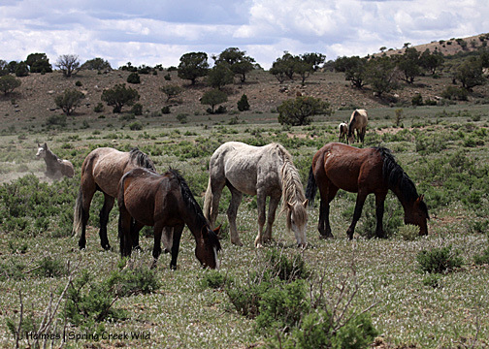

The night was clear, thought Running Wolf, as he stood guarding the horses. The moon was full and rising. The sky was a giant, dark bowl filled with tiny lights. These were travelers, Running Wolf had been told, who began their nightly journeys when the sun had gone.

His horse whinnied softly. The boy patted his horse’s flank. They had been together for three summers, ever since Running Wolf was big enough to straddle him. They knew each other well.

Horses were very important to the Comanches. Men rode them into battle and while hunting buffalo. The whole tribe used them to carry tipis and other belongings from one campsite to the next.

Running Wolf rubbed his sore shoulder. He had fallen while learning to guide his horse with only his knees. All the boys were taught to ride this way, though they fell many times in the learning. But falls did not matter. Once Running Wolf learned this skill, his hands would be free to hold a bow or a shield.

**1**

Running Wolf shifted his weight from one foot to the other. When the moon was overhead, his friend Yellow Star would take his place. Until then, he needed to stay alert. After three more years of training he would be expected to stay awake all night.

Another guard was just barely visible on the far side of the herd. Running Wolf did not call out to him. Four boys in all were watching the herd. They were not playing a game. Some tribes stole horses from other tribes. Horses were very valuable. Sometimes hunters spent several days and nights running down wild horses. Running Wolf and Yellow Star looked forward to that time, when they, too, would catch wild horses and hunt buffalo together.

Suddenly, a twig cracked. Running Wolf pulled out his knife, made from a buffalo’s rib. An owl hooted nearby.

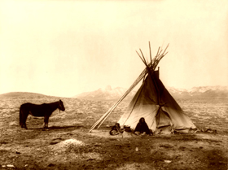

**7**

**10**

Running Wolf ate quickly. He stayed alert to the landscape. It would not be good to have horses stolen while he was busy filling his stomach. In the nearby camp, the last of the fires were dying, the burning buffalo chips turning to ashes. Running Wolf did not think of the warm tipi, of sleeping under a blanket. The cold did not matter. Neither did being alone.

He stood tall in the darkness and watched the night pass.

Running Wolf smiled and put away his knife. He knew that owl. It was Thundercloud. His friend tried hard, but he really didn’t sound much like an owl at all.

Thundercloud had known the boys would be hungry. The night before, when he had been on guard, no one had remembered to feed him. Tonight he had brought his friends chunks of meat that had been broiled over the fire. He gave the meat to Running Wolf and moved on to find the other guards.

1

3

Read this sentence from paragraph 10 of the passage.

*Running Wolf did not think of the warm tipi, of sleeping under a blanket.*

Based on the sentence above, what does the word tipi mean?

**A** A cone-shaped tent used by Native Americans

**B** A campfire

**C** A stew made with buffalo meat

**D** A wild horse

Why were Running Wolf and three other boys guarding the horses?

**A** Some of the horses are sick.

**B** Another tribe may try to steal them.

**C** Sometimes owls scare them.

**D** To make sure they sleep well

Where do the events of this passage take place?

**A** At a Native American school

**B** Before a cookout with friends

**C** In a Comanche camp at night

**D** Inside a Comanche tipi

Who or what are the travelers that Running Wolf refers to in paragraph 1?

**A** The horses

**B** The stars

**C** The Comanche people

**D** Running Wolf and his friends

2

4

Read this sentence from paragraph 10 of the passage.

He stayed alert to the landscape.

Which word is the **best** synonym for alert?

**A** around

**B** hiding

**C** quickly

**D** attentive

Who is telling this story?

**A** Yellow Star

**B** Thundercloud

**C** A narrator

**D** Running Wolf

5

7

One day, when Running Wolf was older, he would be able to

**A** catch wild horses and hunt buffalo.

**B** have his own horse.

**C** build a tipi for his family.

**D** live with a different tribe.

What mattered the **most** to Running Wolf at the end of the passage?

**A** Eating his dinner

**B** His friends hiding nearby

**C** Listening to the owls at night

**D** His responsibility of guarding the horses

6

8

Horses were very important to the Comanches. Give four examples from the passage to explain why horses were so important to the Comanche people.

|  |
| --- |
| **________________________________________________**  **________________________________________________**  **________________________________________________**  **________________________________________________**  **________________________________________________** |

Native American children helped their families in important ways even at early ages. In what ways does this story show that Running Wolf was aware of the importance of his role in the tribe, even though he was just a young boy?

|  |
| --- |
| **________________________________________________**  **________________________________________________**  **________________________________________________**  **________________________________________________**  **________________________________________________** |